**Appium:**

Adb device

Adb kill-server

Adb start-server

To connect wifi: adb tcpip 5555

adb connect 192.168.0.101:5555

Again check either the device connected with wifi name

C:\Users\Venkatesh>abb shell

'abb' is not recognized as an internal or external command,

operable program or batch file.

C:\Users\Venkatesh>adb shell

1|shell@HWLUA-L6735:/ $ dumpsys window windows | grep -E 'mCurrentFocus'

mCurrentFocus=Window{201654 u0 com.android.vending/com.android.vending.AssetBrowserActivity}

shell@HWLUA-L6735:/ $ dumpsys window windows | grep -E 'mCurrentFocus'

mCurrentFocus=Window{27df0c84 u0 com.huawei.android.launcher/com.huawei.android.launcher.Launcher}

**System Paths:**

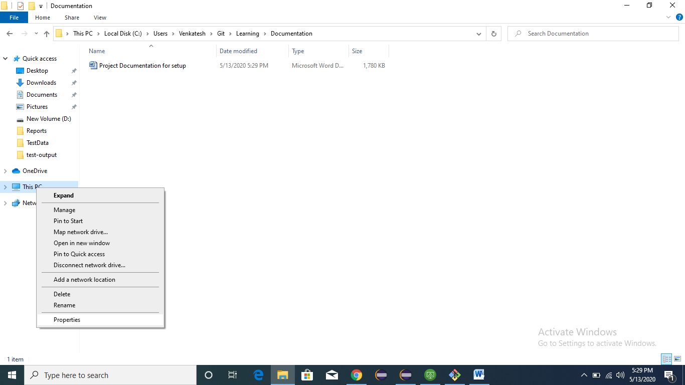

Advance system settings:

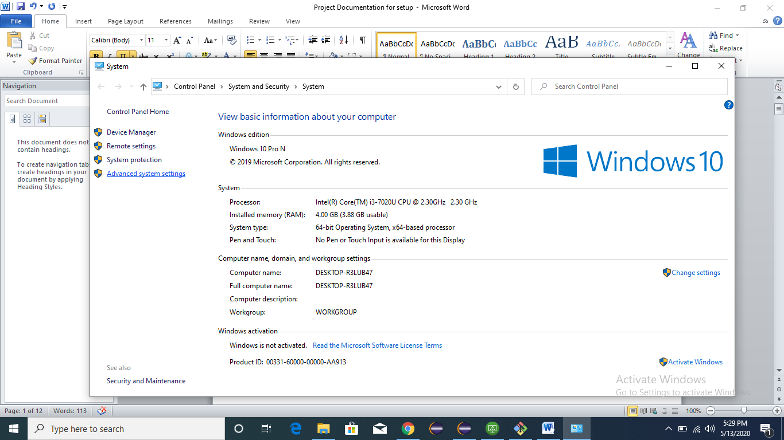

Click on environment settings

Observe java_home and maven home in the below screen

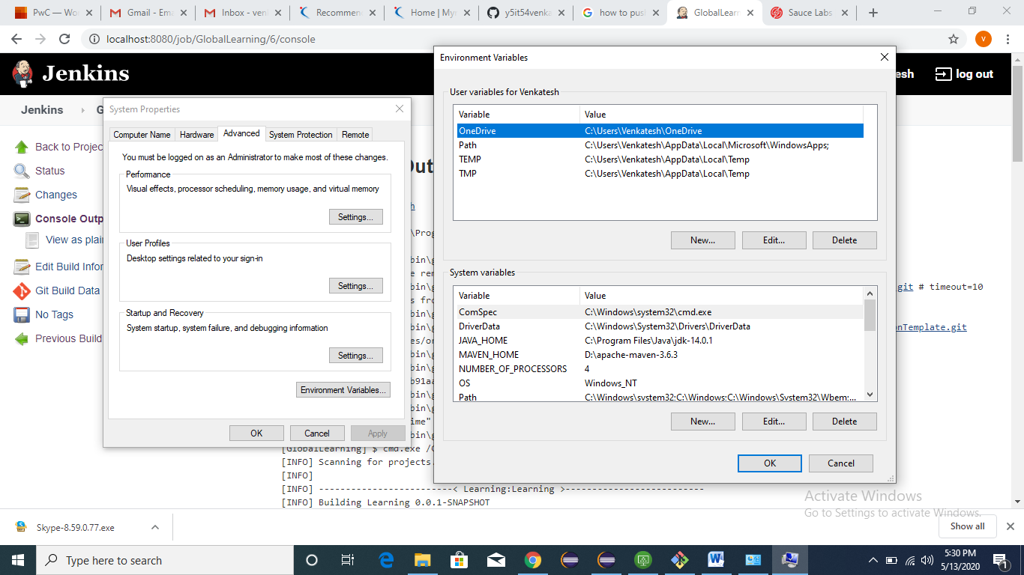

Path

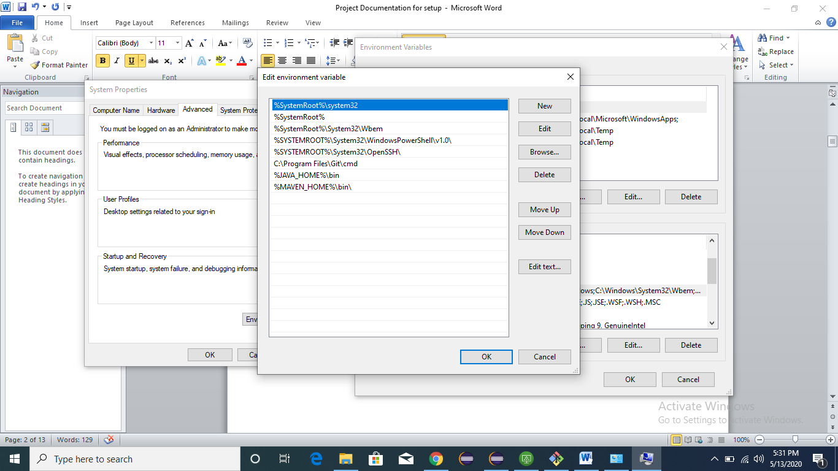

**Git Repo Creation from bash command:**

git init

git add .

git commit -m "First time"

git config --global user.email "vraomailapalli@gmail.com"

git remote add origin https://github.com/y5it54venkatesh/GlobalLearning.git

git push -u origin master

git config user.name "y5it54venkatesh"

**Jenkins Plugins:**

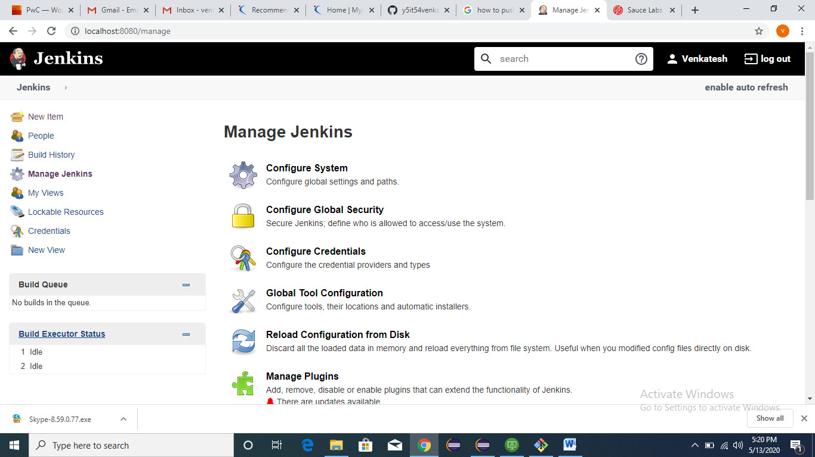

Click on Global Tool Configuration,

Double check Javapath, Maven and Git in the below screenshots:-

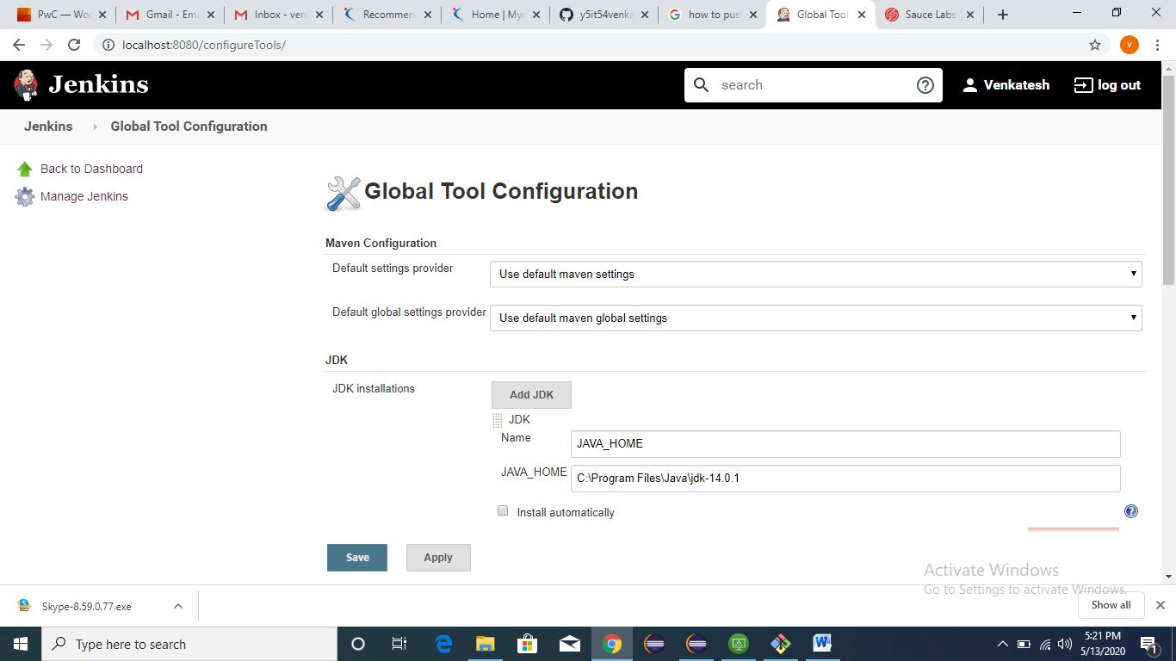

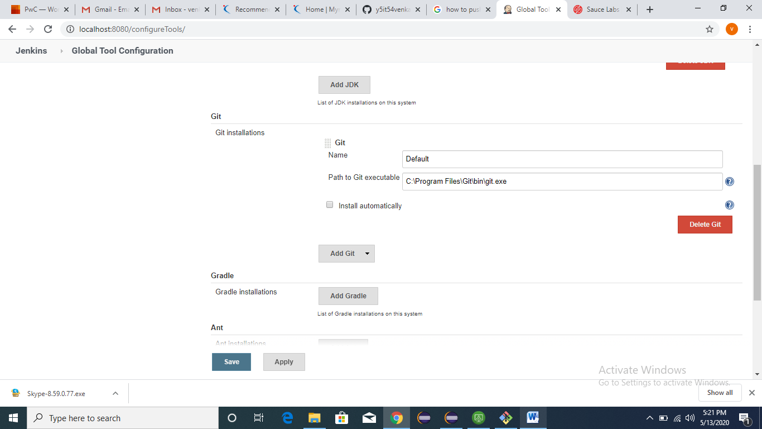

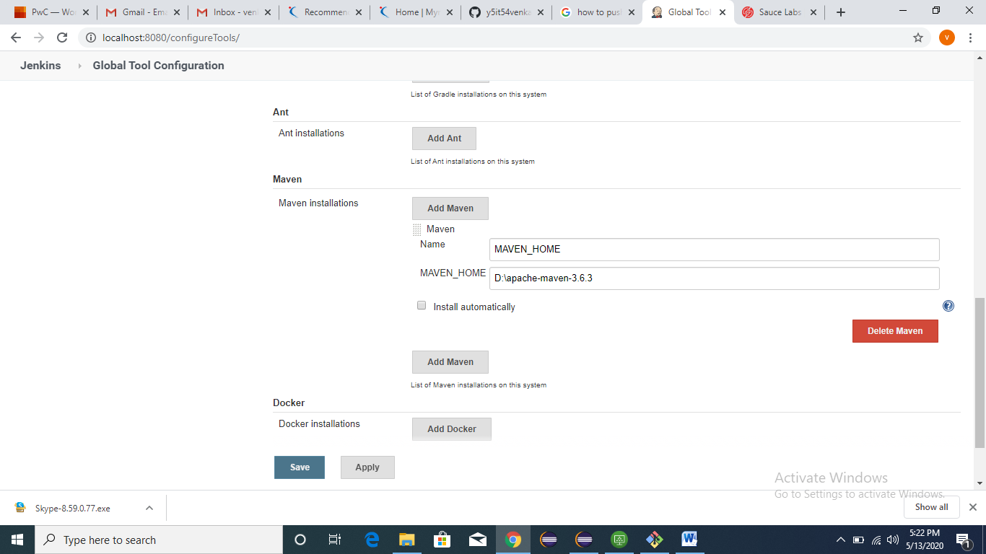

Click on new item:-

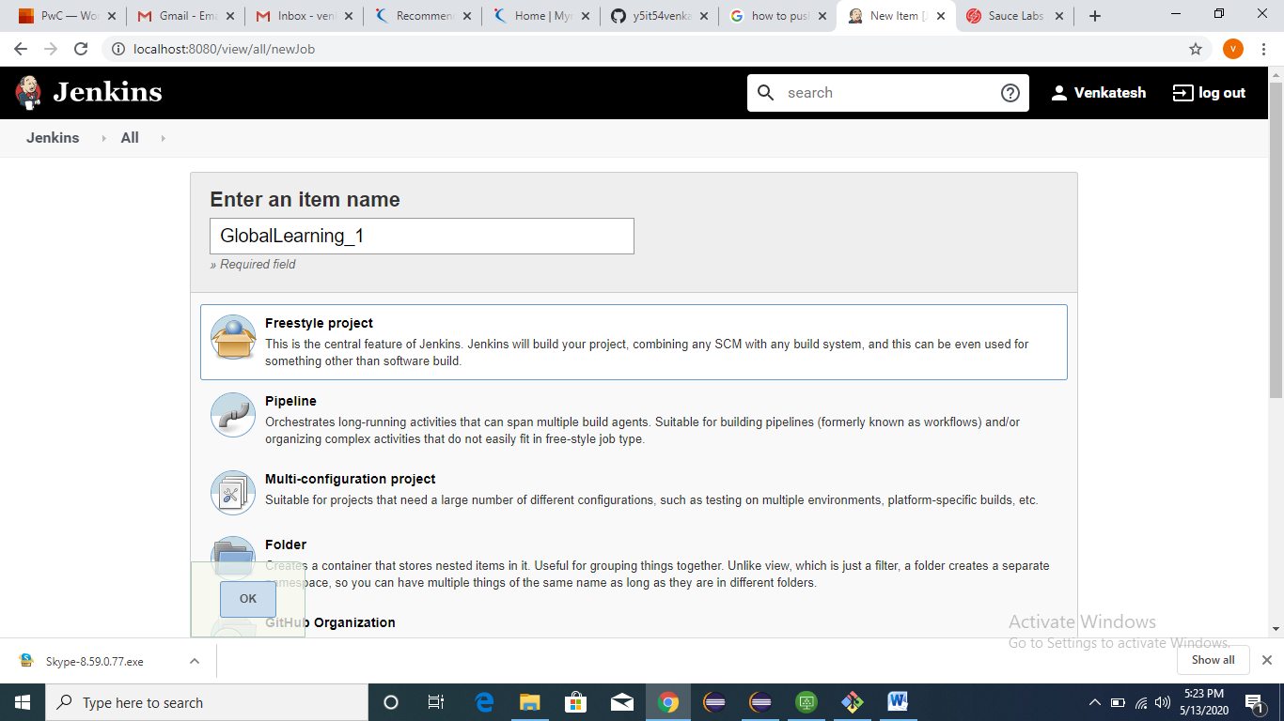

Enter project description

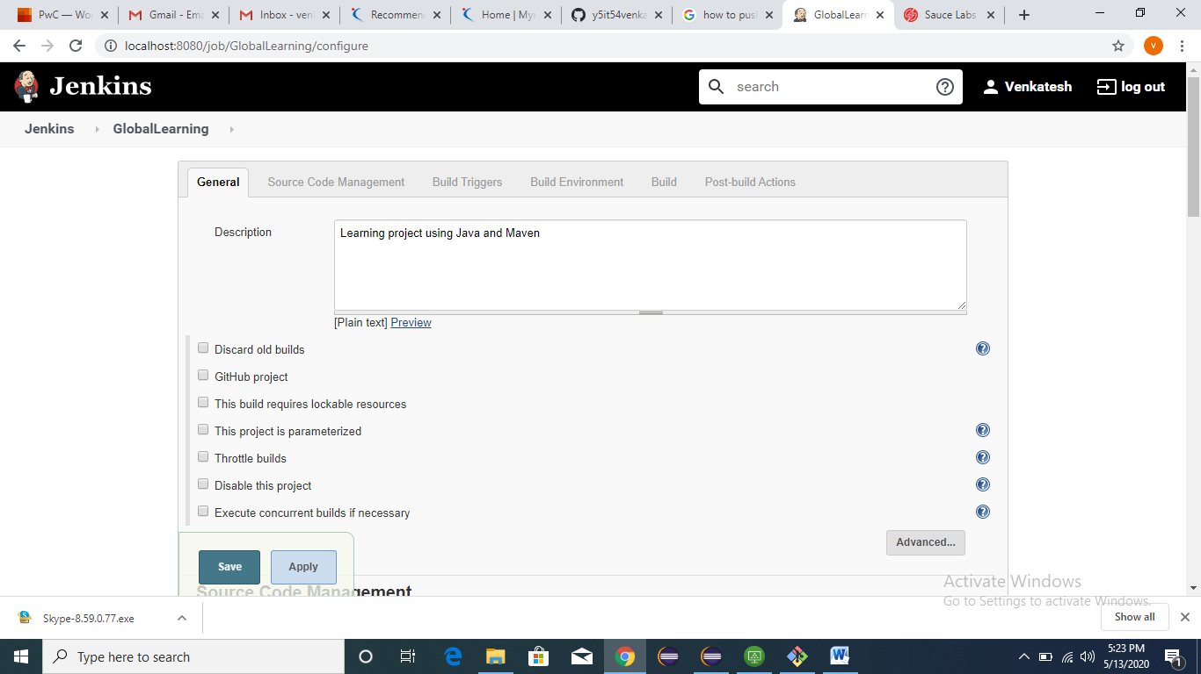

Enter git repo URL, By default here is public

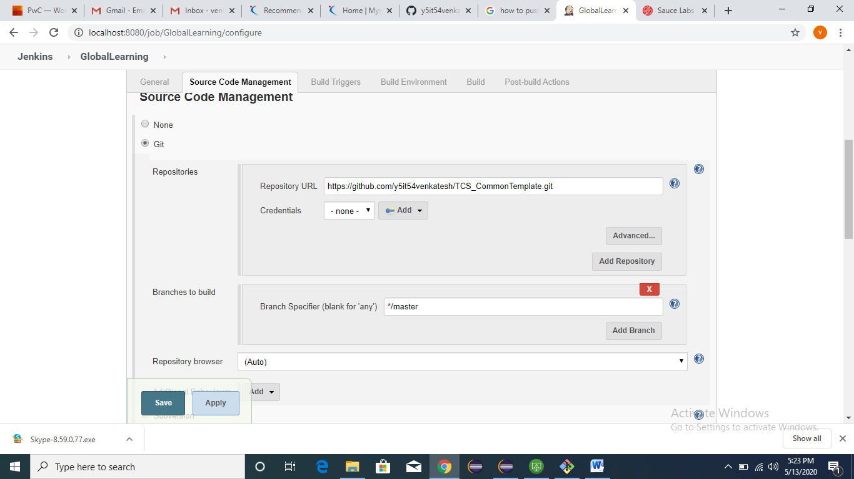

Build with the “Invoke top level maven targets”

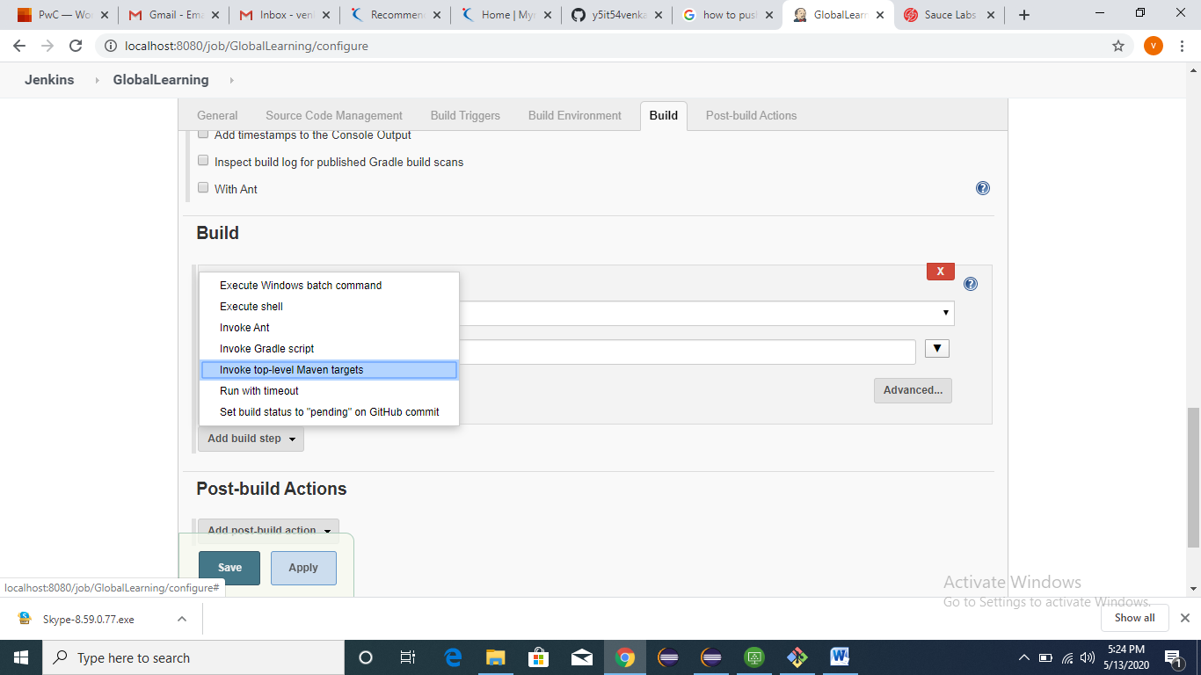

Need to pass goal, i.e clean install

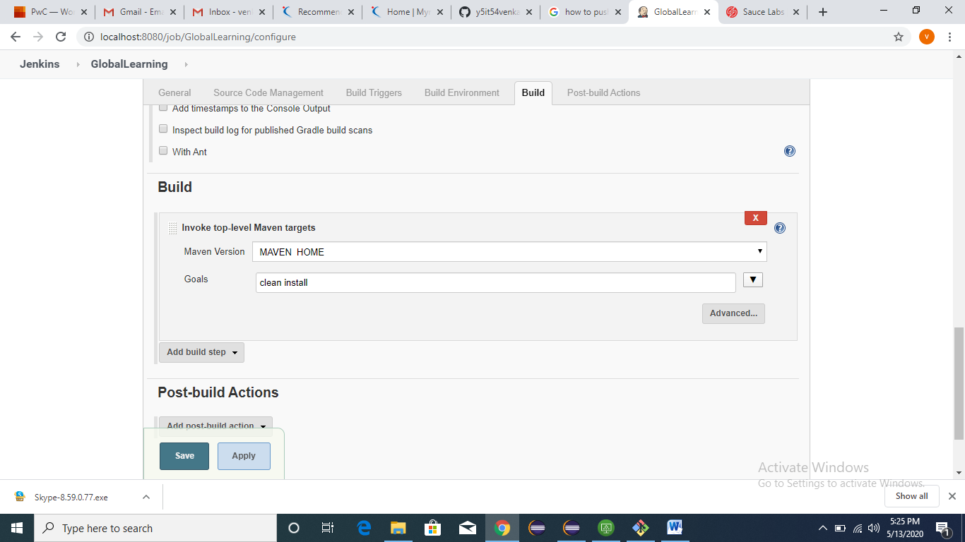

Home page :

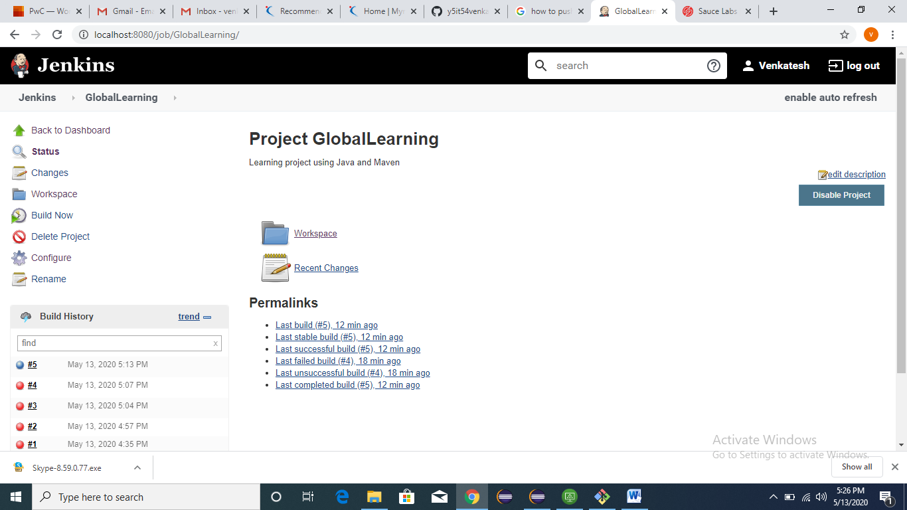

Click on work space , here our project should display



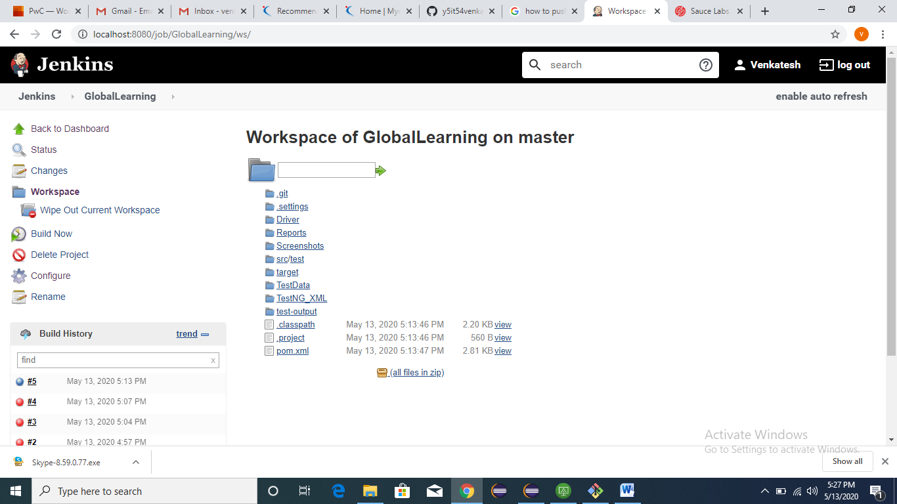

Click on Build now to start execution

Select Build history:-

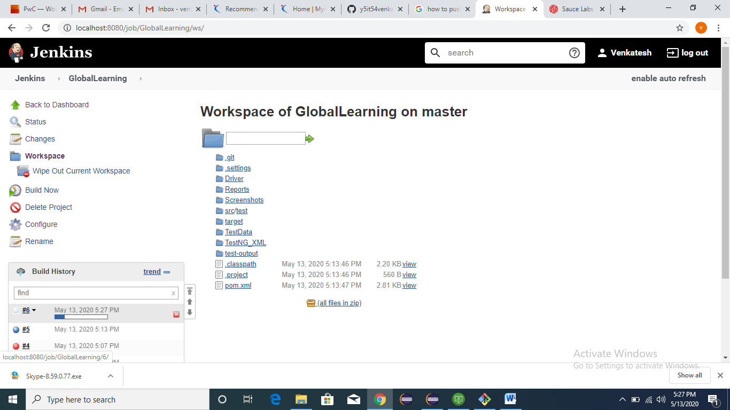

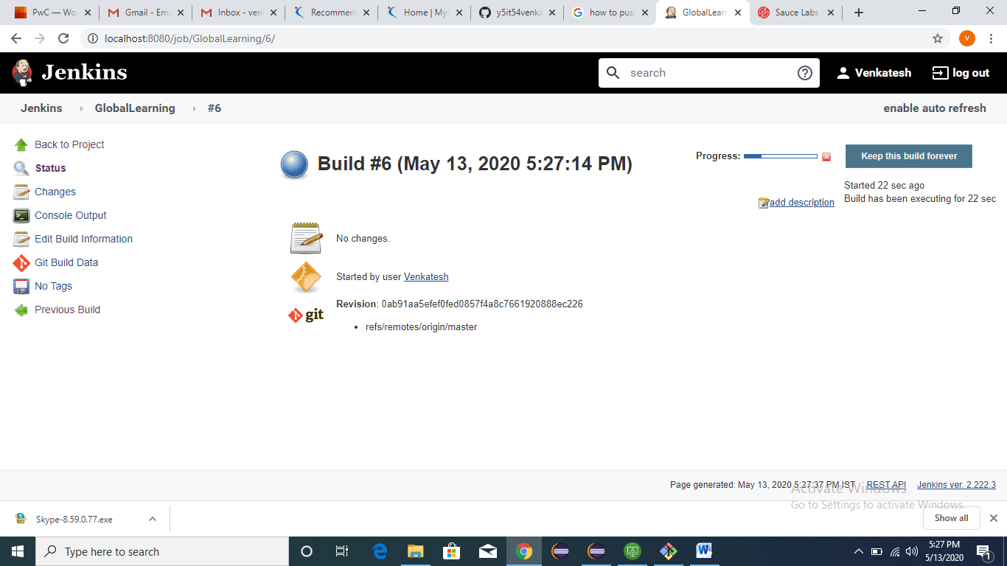

Click on console output

